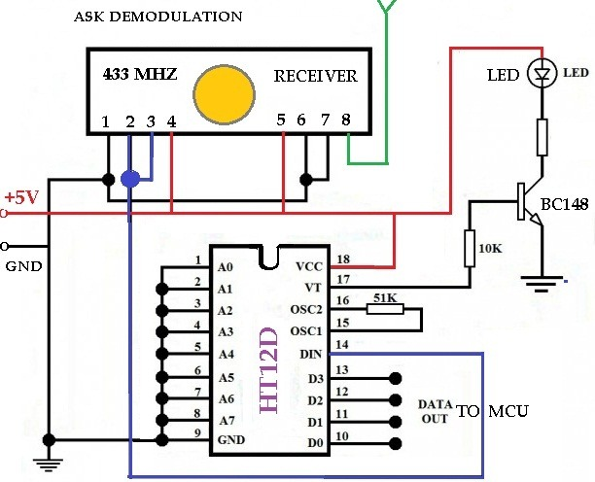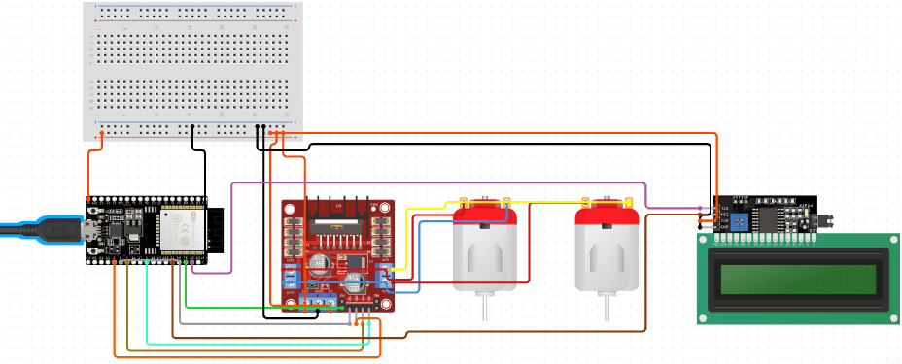

**RECEIVER CIRCUIT DIAGRAM**

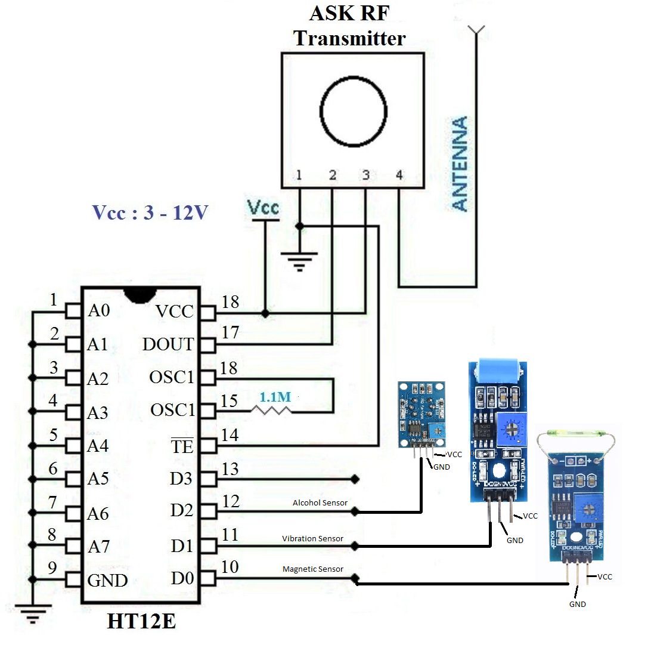

**TRANSMITTER CIRCUIT DIAGRAM**